Discover INFOhio’s Ages 3-5 Digital Learning Pathway

Prepare early learners for future success through INFOhio’s Ages 3-5 Digital Learning Pathway.
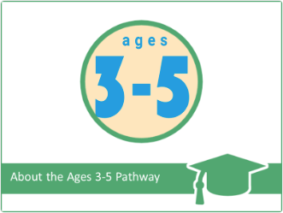
INFOhio's Learning Pathways are designed to meet the needs of PreK-12 educators: flexible and collaborative with viable credit options. The Ages 3-5 Digital Content Learning Pathway provides training on INFOhio's resources for early learning and how to integrate technology use into the preschool and kindergarten classroom. Take all five classes and earn 10 contact hours and a digital badge, or just take one class as needed to earn the credit you need.

Find the Ages 3-5 Digital Learning Pathway – and more – on INFOhio Campus. For questions, please contact INFOhio at support.infohio.org.

INFOhio Blog Series: Developing Social Emotional Digital Content

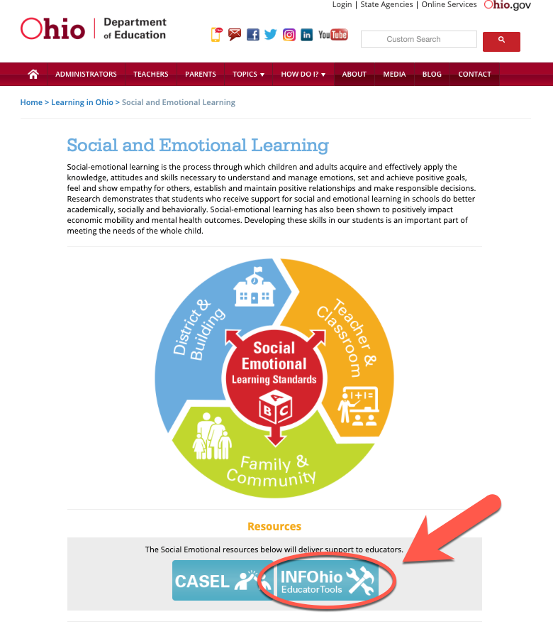
INFOhio has you covered with resources that support Ohio’s Social Emotional Learning Standards.

INFOhio participated with the Ohio Department of Education during the advisory and development process of the Social Emotional Learning Standards. INFOhio resources support social and emotional learning through a variety of content, approaches, and media to teach social-emotional competencies. To help educators find digital content that supports the SEL standards, INFOhio developed a grade-specific blog series: “Develop SEL in grades K-2, 3-5, 6-8, and 9-12 with INFOhio’s Resources.”

Looking for more high-quality resources aligned to SEL standards? Check out INFOhio’s Educator Tools, now linked from ODE’s Social Emotional Learning Standards website.

If you have questions about INFOhio’s resources for SEL, please visit support.infohio.org.


Tell Us How You Use Educator Tools

Help INFOhio learn more about how you use Educator Tools. Visit infohio.org/educator-tools and complete the brief survey that pops up or click this link to go directly to the survey: https://www.surveymonkey.com/r/EducatorTools2019.

Experience BLUEcloud from INFOhio
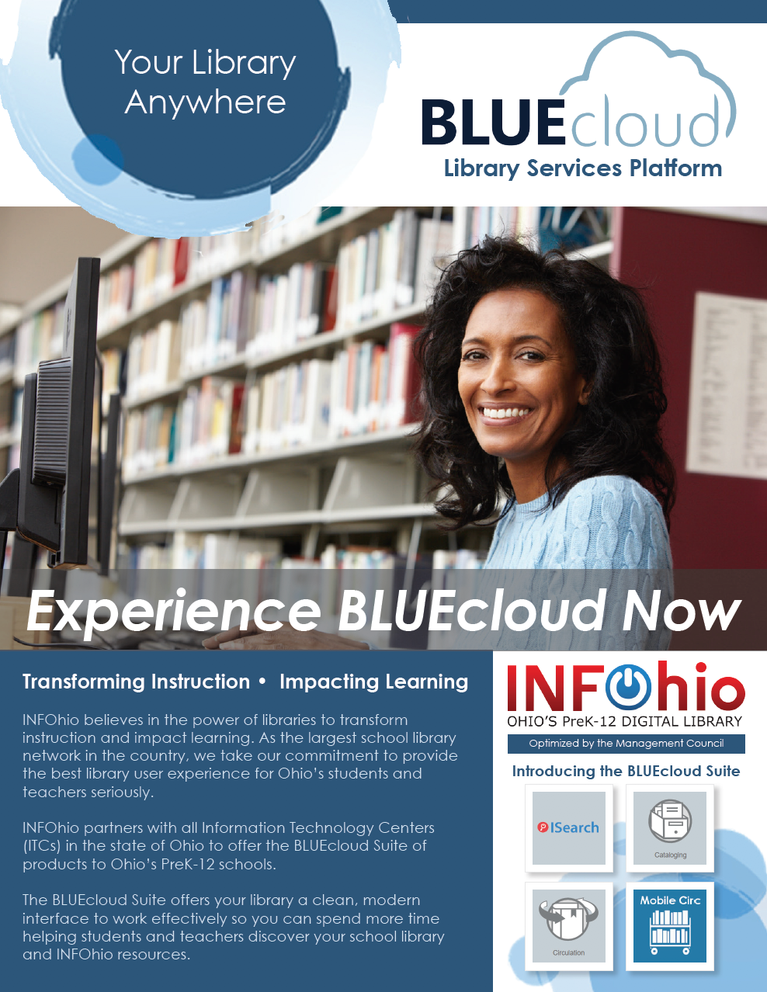
INFOhio believes in the power of libraries to transform instruction and impact learning. As the largest school library network in the country, INFOhio is committed to providing the best library user experience for Ohio’s students and teachers.

INFOhio partners with all of Ohio’s Information Technology Centers (ITCs) to offer the BLUEcloud Suite of products to Ohio’s PreK-12 schools. The BLUEcloud Suite offers your library a clean, modern interface to work effectively so you can spend more time helping students and teachers discover your school library and INFOhio resources.

Share the power of the BLUEcloud Suite with printable fliers. Print one, two, or all six pages: choose the pages that work for you. Ask your regional ITC or INFOhio all your questions about the BLUEcloud Suite of products at support.infohio.org.

Updates to INFOhio’s IWonder to
Support Ohio’s Cyber Club Toolkit

Are you looking for cyber resources, coordinating a cyber club, or building awareness about online safety with your students? Check out INFOhio’s Open Space and the updates to IWonder!

INFOhio has supported the work of the Ohio Cyber Collaboration Committee (OC³) to bring cyber security resources to educators through the Ohio Cyber Club Toolkit (OC²). The toolkit, housed on INFOhio’s Open Space platform, provides direction and resources for cyber club advisors on starting and running cyber clubs in their school or organization.
To support students and teachers by building awareness about online safety and careers in technology, INFOhio has added four new categories to IWonder. Within “Do you want to learn more about technology” you will find three new modules:

- Do you want to learn more about cybersecurity?
- Do you want to learn more about online safety?
- Do you want to learn more about ethical hacking?

Do you want to learn more about information technology careers? has been added to the “Do you know what you want to be when you grow up?” module.

Visit the Ohio Cyber Club Toolkit and IWonder for resources that support students as they learn more about cyber security. For more information, please contact INFOhio at support.infohio.org.

